

Ashland
Music Lover’s Weekend

$50 ($105 value), PACKAGE INCLUDES:

Aug 18: King Edward & the BD’s (ASP)
Aug 19: King Teddy (Bluemont)

- 2 tickets to Ashland Street Parties, with $10 food voucher ($30 value)

- 2 tickets to Bluemont Ashland, with picnic basket & dinner ($30 value)
- The Iron Horse restaurant Sunday brunch gift certificate ($25 value)
- Trackside restaurant gift certificate ($10 value)
- The Caboose Wine and Cheese gift certificate ($10 value)
- Discount rate at the Hampton Inn- Ashland
Buy package at Hampton Inn, Hanover Arts & Activities Center, Hometown Realty, Capital Bank, and the Ashland Visitor Center

CONTACT: 804-798-9131 for more information

PRESENTED BY:
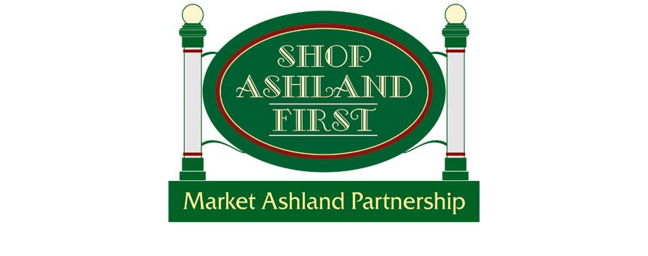

Ashlandstreetparties.com shopashlandfirst.com bluemontinashland.blogspot.com

